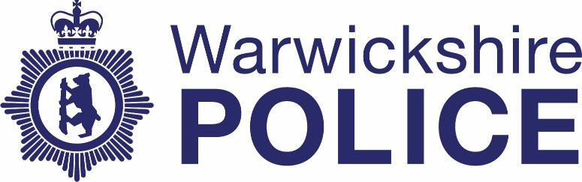

Chief Officers’ contact with the media
Date: July – September 2022
Warwickshire Police publishes information about contact between our Chief Officer team and the media. The information is published quarterly. If you have any questions about this information please contact the Corporate Communications team on news@warkwickshire.pnn.police.uk

 | Officer | Media | Topic
July
July 7th | CC Tedds | Stratford Herald  Nuneaton News | 12 months in post as Chief Constable and focus on crime in Nuneaton
August | N/A | N/A | N/A
September | N/A | N/A | N/A

