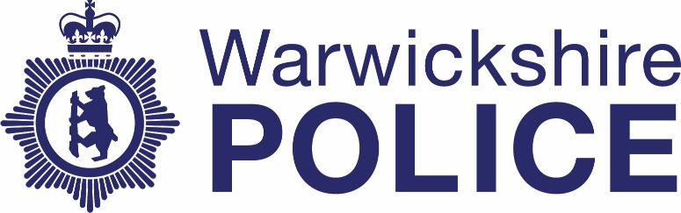

Chief Officers’ contact with the media
Date: April – June 2022
Warwickshire Police publishes information about contact between our Chief Officer team and the media. The information is published quarterly. If you have any questions about this information please contact the Corporate Communications team on news@warkwickshire.pnn.police.uk

 | Officer | Media | Topic
April | N/A | N/A | N/A
May | N/A | N/A | N/A
June
June 20th | DCC Franklin-Smith in national capacity – organised by NPCC | Tom Swarbrick - LBC | Burglary

