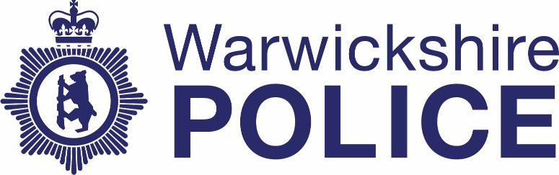

Chief Officers’ contact with the media
Date: July – September 2021
Warwickshire Police publishes information about contact between our Chief Officer team and the media. The information is published quarterly. If you have any questions about this information please contact the Corporate Communications team on news@warkwickshire.pnn.police.uk

 | Officer | Media | Topic
July
July 1 | Chief Constable Debbie Tedds | Fosse Radio (George Ellison) | Taking on role as CC
July 1 | CC Tedds | Stratford Herald (Benn Lugg) | Starting in role
July 1 | CC Tedds | Free Radio (Richard Thomas) | Starting in role
July 1 | CC Tedds | Police Professional (Tony Thompson) | Starting in role
July 1 | CC Tedds | Police Oracle (Chloe Livadeas) | Starting in role
July 1 | CC Tedds | BBC Midlands Today (Nick Owen) | Starting in role
August
September

