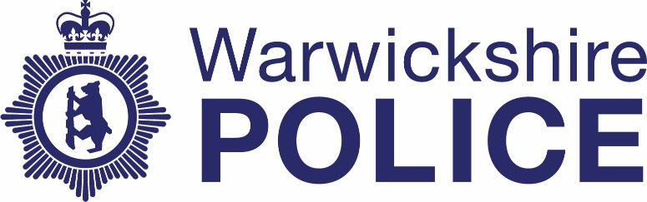

Chief Officers’ contact with the media
Date: October – December 2021
Warwickshire Police publishes information about contact between our Chief Officer team and the media. The information is published quarterly. If you have any questions about this information please contact the Corporate Communications team on news@warkwickshire.pnn.police.uk

 | Officer | Media | Topic
October | N/A | N/A | N/A
November
November 2nd | CC Tedds - organised by NPCC with support from Warwickshire Corporate Comms | Radio 4 | Programme based on a national FOI on vetting across police forces in England, Wales and NI
December | N/A | N/A | N/A

